**Mini project**

Object Oriented Analysis And Design

**Front-end** : HTML,CSS,Js,

**Back-end** : My SQL

**Team members :**

Jaya Surya.S

Jagadish.V

Harshavardhan.R

INTRODUCTION:

**Stock Management System**is a process of managing and locating objector materials. In common usage, the term may also refer to just the software components. According to (Kotler, 2000), stock management refers to all the activities involved in developing and managing the stock levels of raw materials, semi-finished materials (work-in- progress) and finished good so that adequate supplies are available and the costs of over or under stocks are low.  (Rosenblatt, 1977) says: “The cost of maintaining stock is included in the final price paid by the consumer. Good in stock represents a cost to their owner. The manufacturer has the expense of materials and labour. The wholesaler also has funds tied up”. Therefore, the basic goal of the researchers is to maintain a level of stock that will provide optimum stock at lowest cost.

**Login page :**

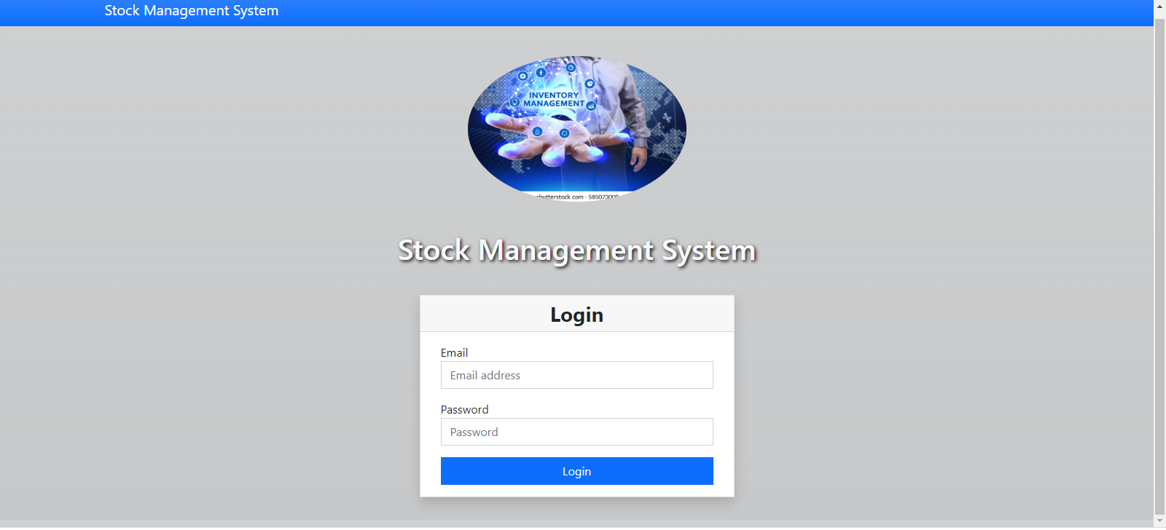

**Home page :**

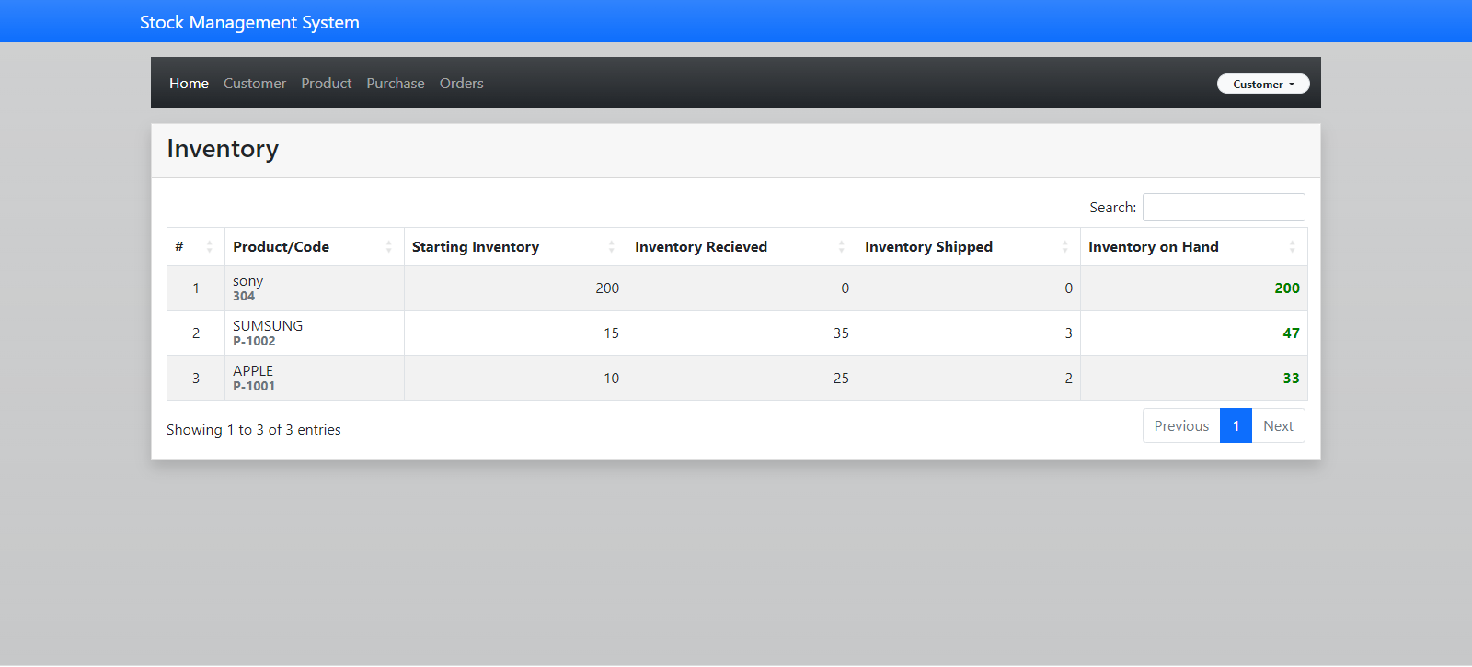

**Product page:**

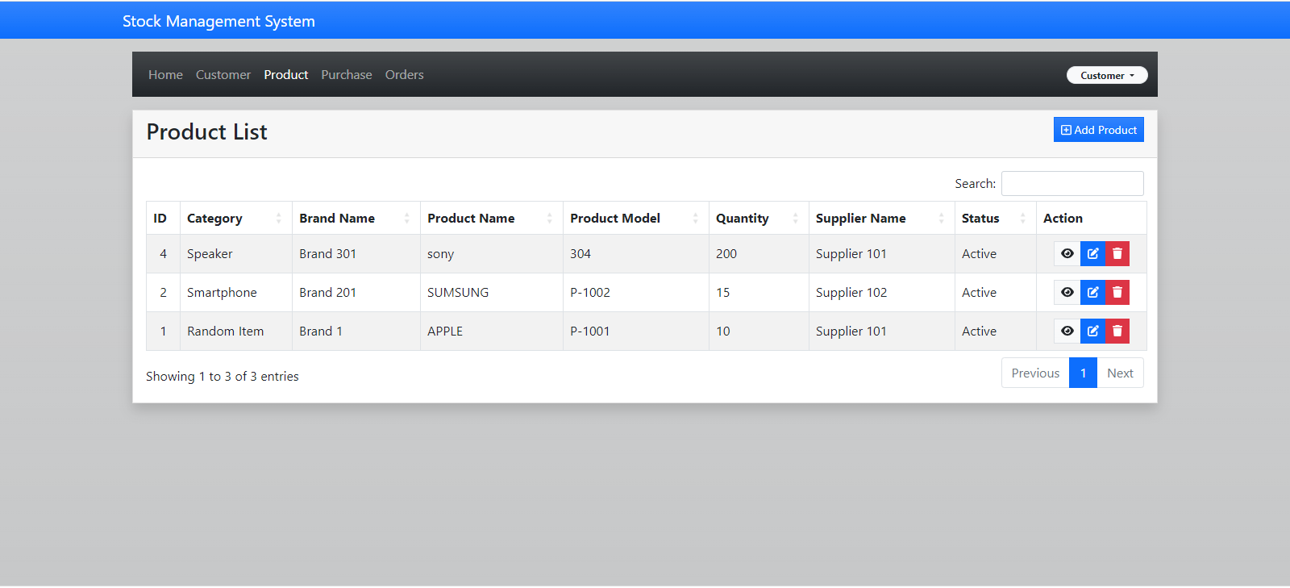

**Order page:**

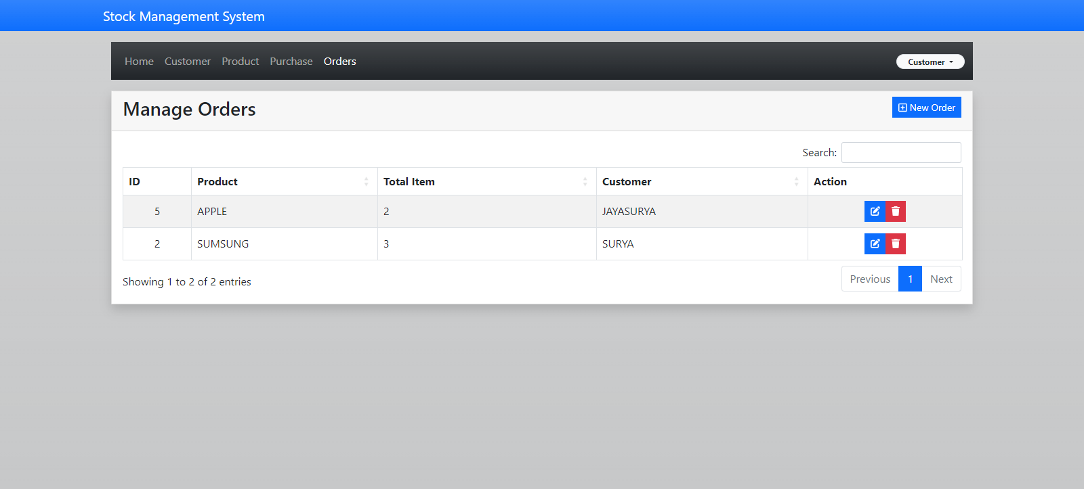

**Customer page:**

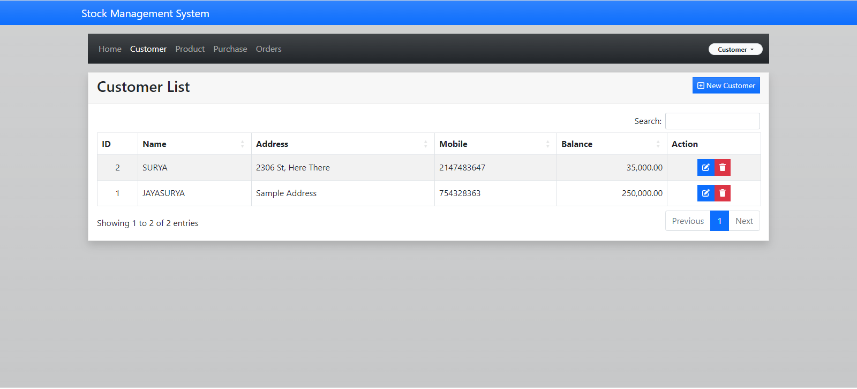

**Coding:**

**Ims_db.sql**

-- phpMyAdmin SQL Dump

-- version 5.1.3

-- https://www.phpmyadmin.net/

--

-- Host: 127.0.0.1

-- Generation Time: Jun 20, 2022 at 10:21 AM

-- Server version: 10.4.24-MariaDB

-- PHP Version: 8.1.5

SET SQL_MODE = "NO_AUTO_VALUE_ON_ZERO";

START TRANSACTION;

SET time_zone = "+00:00";

--

-- Database: `ims_db`

--

-- --------------------------------------------------------

--

-- Table structure for table `ims_brand`

--

CREATE TABLE `ims_brand` (

  `id` int(11) NOT NULL,

  `categoryid` int(11) NOT NULL,

  `bname` varchar(250) NOT NULL,

  `status` enum('active','inactive') NOT NULL

) ENGINE=InnoDB DEFAULT CHARSET=latin1;

--

-- Dumping data for table `ims_brand`

--

INSERT INTO `ims_brand` (`id`, `categoryid`, `bname`, `status`) VALUES

(1, 2, 'Brand 1', 'active'),

(2, 2, 'Brand 2', 'active'),

(3, 2, 'Brand 3', 'active'),

(4, 1, 'Brand 201', 'active'),

(5, 1, 'Brand 202', 'active'),

(6, 1, 'Brand 203', 'active'),

(7, 3, 'Brand 301', 'active'),

(8, 3, 'Brand 302', 'active'),

(9, 3, 'Brand 303', 'active');

-- --------------------------------------------------------

--

-- Table structure for table `ims_category`

--

CREATE TABLE `ims_category` (

  `categoryid` int(11) NOT NULL,

  `name` varchar(250) NOT NULL,

  `status` enum('active','inactive') NOT NULL

) ENGINE=InnoDB DEFAULT CHARSET=latin1;

--

-- Dumping data for table `ims_category`

--

INSERT INTO `ims_category` (`categoryid`, `name`, `status`) VALUES

(1, 'Smartphone', 'active'),

(2, 'Random Item', 'active'),

(3, 'Speaker', 'active');

-- --------------------------------------------------------

--

-- Table structure for table `ims_customer`

--

CREATE TABLE `ims_customer` (

  `id` int(11) NOT NULL,

  `name` varchar(200) NOT NULL,

  `address` text NOT NULL,

  `mobile` int(50) NOT NULL,

  `balance` double(10,2) NOT NULL

) ENGINE=InnoDB DEFAULT CHARSET=latin1;

--

-- Dumping data for table `ims_customer`

--

INSERT INTO `ims_customer` (`id`, `name`, `address`, `mobile`, `balance`) VALUES

(1, 'Mark Cooper', 'Sample Address', 2147483647, 25000.00),

(2, 'George Wilson', '2306 St, Here There', 2147483647, 35000.00);

-- --------------------------------------------------------

--

-- Table structure for table `ims_order`

--

CREATE TABLE `ims_order` (

  `order_id` int(11) NOT NULL,

  `product_id` varchar(255) NOT NULL,

  `total_shipped` int(11) NOT NULL,

  `customer_id` int(11) NOT NULL,

  `order_date` timestamp NOT NULL DEFAULT current_timestamp()

) ENGINE=InnoDB DEFAULT CHARSET=latin1;

--

-- Dumping data for table `ims_order`

--

INSERT INTO `ims_order` (`order_id`, `product_id`, `total_shipped`, `customer_id`, `order_date`) VALUES

(1, '1', 5, 1, '2022-06-20 08:20:40'),

(2, '2', 3, 2, '2022-06-20 08:20:48');

-- --------------------------------------------------------

--

-- Table structure for table `ims_product`

--

CREATE TABLE `ims_product` (

  `pid` int(11) NOT NULL,

  `categoryid` int(11) NOT NULL,

  `brandid` int(11) NOT NULL,

  `pname` varchar(300) NOT NULL,

  `model` varchar(255) NOT NULL,

  `description` text NOT NULL,

  `quantity` int(11) NOT NULL,

  `unit` varchar(150) NOT NULL,

  `base_price` double(10,2) NOT NULL,

  `tax` decimal(4,2) NOT NULL,

  `minimum_order` double(10,2) NOT NULL,

  `supplier` int(11) NOT NULL,

  `status` enum('active','inactive') NOT NULL,

  `date` date NOT NULL

) ENGINE=InnoDB DEFAULT CHARSET=latin1;

--

-- Dumping data for table `ims_product`

--

INSERT INTO `ims_product` (`pid`, `categoryid`, `brandid`, `pname`, `model`, `description`, `quantity`, `unit`, `base_price`, `tax`, `minimum_order`, `supplier`, `status`, `date`) VALUES

(1, 2, 1, 'Product 101', 'P-1001', 'usce auctor faucibus efficitur.', 10, 'Bottles', 500.00, '12.00', 1.00, 1, 'active', '0000-00-00'),

(2, 1, 4, 'Product 102', 'P-1002', 'Proin vehicula mi pulvinar ipsum ornare tincidunt.', 15, 'Box', 7500.00, '12.00', 1.00, 2, 'active', '0000-00-00'),

(3, 3, 7, 'Product 103', 'P-1003', 'Integer interdum, odio eget mattis venenatis', 20, 'Bags', 350.00, '12.00', 1.00, 3, 'active', '0000-00-00');

-- --------------------------------------------------------

--

-- Table structure for table `ims_purchase`

--

CREATE TABLE `ims_purchase` (

  `purchase_id` int(11) NOT NULL,

  `supplier_id` varchar(255) NOT NULL,

  `product_id` varchar(255) NOT NULL,

  `quantity` varchar(255) NOT NULL,

  `purchase_date` timestamp NOT NULL DEFAULT current_timestamp()

) ENGINE=InnoDB DEFAULT CHARSET=latin1;

--

-- Dumping data for table `ims_purchase`

--

INSERT INTO `ims_purchase` (`purchase_id`, `supplier_id`, `product_id`, `quantity`, `purchase_date`) VALUES

(1, '1', '1', '25', '2022-06-20 08:20:07'),

(2, '2', '2', '35', '2022-06-20 08:20:14'),

(3, '3', '3', '10', '2022-06-20 08:20:29');

-- --------------------------------------------------------

--

-- Table structure for table `ims_supplier`

--

CREATE TABLE `ims_supplier` (

  `supplier_id` int(11) NOT NULL,

  `supplier_name` varchar(200) NOT NULL,

  `mobile` varchar(50) NOT NULL,

  `address` text NOT NULL,

  `status` enum('active','inactive') NOT NULL

) ENGINE=InnoDB DEFAULT CHARSET=latin1;

--

-- Dumping data for table `ims_supplier`

--

INSERT INTO `ims_supplier` (`supplier_id`, `supplier_name`, `mobile`, `address`, `status`) VALUES

(1, 'Supplier 101', '09645987123', 'Over Here', 'active'),

(2, 'Supplier 102', '094568791252', 'Over There', 'active'),

(3, 'Supplier 103', '09789897879', 'Anywhere There', 'active');

-- --------------------------------------------------------

--

-- Table structure for table `ims_user`

--

CREATE TABLE `ims_user` (

  `userid` int(11) NOT NULL,

  `email` varchar(200) NOT NULL,

  `password` varchar(200) NOT NULL,

  `name` varchar(200) NOT NULL,

  `type` enum('admin','member') NOT NULL,

  `status` enum('Active','Inactive') NOT NULL

) ENGINE=InnoDB DEFAULT CHARSET=latin1;

--

-- Dumping data for table `ims_user`

--

INSERT INTO `ims_user` (`userid`, `email`, `password`, `name`, `type`, `status`) VALUES

(1, 'admin@123.com', '0192023a7bbd73250516f069df18b500', 'Administrator', 'admin', 'InActive');

INSERT INTO `ims_user` (`userid`, `email`, `password`, `name`, `type`, `status`) VALUES

(2, 'surya@123.com', '1f3870be274f6c49b3e31a0c6728957f', 'Customer', 'Customer', 'Active');

INSERT INTO `ims_user` (`userid`, `email`, `password`, `name`, `type`, `status`) VALUES

(3, 'jagadish@123.com', '45125a00b243e993fae5f24a0b37efd6', 'Administrator', 'admin', 'Active');

--

-- Indexes for dumped tables

--

--

-- Indexes for table `ims_brand`

--

ALTER TABLE `ims_brand`

  ADD PRIMARY KEY (`id`);

--

-- Indexes for table `ims_category`

--

ALTER TABLE `ims_category`

  ADD PRIMARY KEY (`categoryid`);

--

-- Indexes for table `ims_customer`

--

ALTER TABLE `ims_customer`

  ADD PRIMARY KEY (`id`);

--

-- Indexes for table `ims_order`

--

ALTER TABLE `ims_order`

  ADD PRIMARY KEY (`order_id`);

--

-- Indexes for table `ims_product`

--

ALTER TABLE `ims_product`

  ADD PRIMARY KEY (`pid`);

--

-- Indexes for table `ims_purchase`

--

ALTER TABLE `ims_purchase`

  ADD PRIMARY KEY (`purchase_id`);

--

-- Indexes for table `ims_supplier`

--

ALTER TABLE `ims_supplier`

  ADD PRIMARY KEY (`supplier_id`);

--

-- Indexes for table `ims_user`

--

ALTER TABLE `ims_user`

  ADD PRIMARY KEY (`userid`);

--

-- AUTO_INCREMENT for dumped tables

--

--

-- AUTO_INCREMENT for table `ims_brand`

--

ALTER TABLE `ims_brand`

  MODIFY `id` int(11) NOT NULL AUTO_INCREMENT, AUTO_INCREMENT=10;

--

-- AUTO_INCREMENT for table `ims_category`

--

ALTER TABLE `ims_category`

  MODIFY `categoryid` int(11) NOT NULL AUTO_INCREMENT, AUTO_INCREMENT=4;

--

-- AUTO_INCREMENT for table `ims_customer`

--

ALTER TABLE `ims_customer`

  MODIFY `id` int(11) NOT NULL AUTO_INCREMENT, AUTO_INCREMENT=3;

--

-- AUTO_INCREMENT for table `ims_order`

--

ALTER TABLE `ims_order`

  MODIFY `order_id` int(11) NOT NULL AUTO_INCREMENT, AUTO_INCREMENT=3;

--

-- AUTO_INCREMENT for table `ims_product`

--

ALTER TABLE `ims_product`

  MODIFY `pid` int(11) NOT NULL AUTO_INCREMENT, AUTO_INCREMENT=4;

--

-- AUTO_INCREMENT for table `ims_purchase`

--

ALTER TABLE `ims_purchase`

  MODIFY `purchase_id` int(11) NOT NULL AUTO_INCREMENT, AUTO_INCREMENT=4;

--

-- AUTO_INCREMENT for table `ims_supplier`

--

ALTER TABLE `ims_supplier`

  MODIFY `supplier_id` int(11) NOT NULL AUTO_INCREMENT, AUTO_INCREMENT=4;

--

-- AUTO_INCREMENT for table `ims_user`

--

ALTER TABLE `ims_user`

  MODIFY `userid` int(11) NOT NULL AUTO_INCREMENT, AUTO_INCREMENT=3;

COMMIT;

**Result:**

**Thus the Mini project for Stock maintenance system was developed and executed successfully.**